Alight
CS Pro



Friday, September 23, 2022

This work was performed under contract to:
Alight

For more information contact:
Ninad Purohit
Senior Security Consultant
Muhammad Farhan
Security Consultant



Proprietary Statement
© 2022 !Unexpected End of FormulaSynopsys, Inc. All rights reserved worldwide. No part or parts of this documentation may be reproduced, translated, stored in any electronic retrieval system, transmitted in any form or by any means, electronic, mechanical, photocopying, recording or otherwise, without prior written permission of the copyright owner. Synopsys, Inc. retains the exclusive title to all intellectual property rights relating to this documentation.
The information in this documentation is subject to change without notice and should not be construed as a commitment by Synopsys, Inc. Synopsys, Inc. makes no representations or warranties, express or implied, with respect to the documentation and shall not be liable for any damages, including any indirect, incidental, consequential damages (such as loss of profit, loss of use of assets, loss of business opportunity, loss of data or claims for or on behalf of user’s customers), that may be suffered by the user.
Synopsys and the Synopsys logo are trademarks of Synopsys, Inc. Other brands and products are trademarks of their respective owner(s).
Synopsys, Inc.
185 Berry Street, Suite 6500
San Francisco, CA 94107 USA
U.S. Sales: 800.873.8193
International Sales: +1 415.321.5237
Email: sig-info@synopsys.com
www.synopsys.com/software .

version 2020.07

Table of Contents
Table of Contents 3
Document Revision History 4
Contacts 4
Executive Summary 5
1 Introduction 6
1.1 Objective 6
1.2 Scope 6
1.3 Assessment Notes 6
2 Methodology 7
2.1 Assessment Type 7
2.2 Risk Assessment Methodology 7
2.3 Informational Findings 8
2.4 Systemic Findings 8
3 Findings 9
3.1 Summary of Findings 9
3.2 Finding Details 10
3.2.1 High Priority Findings 10
3.2.2 Low Priority Findings 12
3.2.3 Minimal Priority Findings 18

Document Revision History
Version | Modification | Date | Author
1.0 | Security report | 09/23/2022 | Muhammad Farhan
1.1 | Security report review |  | Ninad Purohit

Contacts
Contact | Title | Organization | Phone # | Email Address
Ninad Purohit | Senior Security Consultant | Synopsys, Inc. | +1.312.873.5657 | npurohit@synopsys.com
Muhammad Farhan | Security Consultant | Synopsys, Inc. |  | mfarhan@synopsys.com

Executive Summary
Alight has engaged Synopsys, Inc. to perform a Penetration Test - Standard assessment on CS Pro. The purpose of this assessment was to assess the overall security posture of the application from a grey-box perspective. This includes determining the application’s ability to resist common attack patterns and identifying vulnerable areas in the internal or external interfaces that may be exploited by a malicious user.

During the assessment, Synopsys identified 4 findings characterized as follows:
- 1 High priority finding
- 2 Low priority findings
- 1 Minimal priority findings

While performing the assessment of Service Connect, Synopsys identified that security controls were effective in resisting common attack patterns like:
> Authentication/Authorization Attacks
> Input Validation Attacks

Introduction
Alight engaged Synopsys, Inc. to perform a Penetration Test - Standard assessment on CS Pro thick client application beginning on September 09, 2022 and ending on September 23, 2022.

Objective
The objective of this assessment was to assess the overall security posture of the application from a grey-box perspective. This includes determining the application’s ability to resist common attack patterns and identifying vulnerable areas in the internal or external interfaces that may be exploited by a malicious user.

Scope
The scope of this assessment was limited to components and interfaces specific to Service Connect. The following component were considered in-scope:
- The CS Pro thick client application
The following component were considered out-of-scope:
- The Salesforce web portal

Assessment Notes
Outbound calls feature in the application was not enabled during the penetration test.

Methodology

Assessment Type
Synopsys was engaged to perform a time-boxed manual security assessment against the target application. This assessment involved a deep automated scan using automated scanning tools to discover common vulnerabilities, as well as manual testing. Manual testing includes validation of all issue types covered under the automated scan as well as checks for problems not typically found by automated scanners such as authentication, authorization and business logic flaws.

Risk Assessment Methodology
The severity assigned to each vulnerability was calculated using the NIST 800-30 Revision 1 standard. This standard determines the risk posed by application based on the likelihood an attacker exploits the vulnerability and the impact that it would have on the business.
Likelihood
The difficulty of exploiting the described security vulnerability includes required skill level and the amount of access necessary to visit the element susceptible to the vulnerability. The difficulty is rated with the following values:
- Critical: An attacker is almost certain to initiate the threat event.
- High: An untrained user could exploit the vulnerability or the vulnerability is very obvious and easily accessible.
- Medium: The vulnerability requires some hacking knowledge or access is restricted in some way.
- Low: Exploiting the vulnerability requires application access, significant time, resource or a specialized skillset.
- Minimal: Adversaries are highly unlikely to leverage the vulnerability.
Impact
The impact the vulnerability would have on the organization if it were successfully exploited is rated with the following values:
- Critical: The issue causes multiple severe or catastrophic effects on organizational operations, organizational assets or other organizations.
- High: Exploitation produces severe degradation in mission capability to the point that the organization is not able to perform primary functions or results in damage to organizational assets.
- Medium: Threat events trigger degradation in mission capability to an extent the application is able to perform its primary functions, but their effectiveness is reduced and there may be damage to organizational assets.
- Low: Successful exploitation has limited degradation in mission capability; the organization is able to perform its primary functions, but their effectiveness is noticeably reduced and may result in minor damage to organizational assets.
- Minimal: The threat could have a negligible adverse effect on organizational operations or organizational assets.
Severity
The vulnerability severity is determined using the likelihood and impact weights in the following table:
 |  | Impact
 |  | Minimal | Low | Medium | High | Critical
Likelihood | Critical | Minimal | Low | Medium | High | Critical
Likelihood | High | Minimal | Low | Medium | High | Critical
Likelihood | Medium | Minimal | Low | Medium | Medium | High
Likelihood | Low | Minimal | Low | Low | Low | Medium
Likelihood | Minimal | Minimal | Minimal | Minimal | Low | Low

Informational Findings
In addition to the risk rating methodology discussed above, Synopsys may also label a finding as “Informational” to indicate that a risk rating is not applicable to the finding. This is typically used when there is a best practice violation or potential finding that was not found to be directly exploitable, but still deemed important enough to include in the report.

Systemic Findings
Findings may be labelled as “systemic findings” when Synopsys found more than five instances on multiple pages or functions of the application. In Synopsys’ extensive experience, this often indicates many more yet to be discovered instances within the source code that could affect the security of the application if not resolved systemically. Synopsys recommends that developers identify and resolve the noted issues and design patterns, and then thoroughly search for all remaining instances or patterns and resolve as appropriate.

Findings

Summary of Findings
Finding | Likelihood | Impact | Severity | Status
Certification Validation Disabled | High | High | High | Open
Hard-coded Secrets in Client-side Code | Low | Low | Low | Open
Weak Password Policy | Low | High | Low | Open
Concurrent Sessions | Minimal | Low | Minimal | Open

Finding Details

High Priority Findings

Certification Validation Disabled
Description:
The application overrides the default X509TrustManager with its own implementation that completely disables certificate verification. Failing to validate the certificate reduces the strength of the communication channel to that of HTTP.
The application disables server certificate verification for SSL/TLS connections that it initiates. Without server certificate verification, the application will connect to any server that presents a certificate regardless of whether the certificate was signed by a trusted certificate authority, generated for the host that the app is connecting to, has expired, etc.
The application will not authenticate the server that it is connecting to. Therefore, an attacker can use network-layer attacks to cause the application on a victim's device to connect to his/her server to steal user credentials, supply malicious data to the app, etc.
Instances:
- CS Pro thick client
Steps To Reproduce:
- Decompile the jd-gui application.
- Open the ConnectProClient.jar file present under the lib folder.
- Observe the overridden X509TrustManager in com.hewitt.connectPro.model and com.hewitt.connectPro.metrics.connectivity
- Observer the empty checkServerTrusted methods

Evidence:
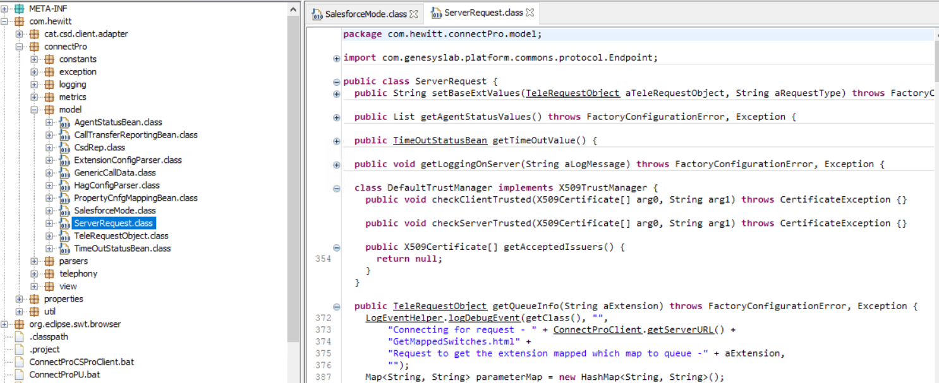
Figure 1 Overridden X509TrustManager to disable validation of certificate
Likelihood: High
Impact: High
Severity: High
CWE ID: 295
Remediation:
Do not bypass the default certificate verification behavior provided by the platform. Adding checks not provided by default (e.g. to perform certificate pinning) is acceptable; however, the default checks should not be bypassed. Any changes to default certificate verification logic must be thoroughly reviewed as part of a security assessment to ensure that it does not cause any unintended side-effects.

Low Priority Findings

Hard-coded Secrets in Client-side Code
Description:
The application binary or a resource within the application package contains a hard-coded secret. Examples of hard-coded secrets may include:
- Passwords
- API keys
- Cryptographic keys
Hard-coded secrets present several problems:
The secret is the same on all devices. An attacker can extract the file containing the secret or reverse engineer the thick client to obtain the hard-coded secret. Once the secret is obtained on one device, it can likely be used to expose the data it protects on any device where the application is installed. It may not be possible to change the secret easily and it could create backward compatibility issues if it is changed in subsequent application versions.
The impact depends on what exactly the secret is used for. For example: * If the secret is used to protect data stored on devices, an attacker who gets access to the protected data on another user's device (e.g. through physical access to a device or through malware running on a device) will be able to decrypt and/or tamper with that data. * If the secret is used to protect device to device or device to server communications, an attacker who can access the protected data (e.g. through network-layer attacks) will be able to decrypt and/or tamper with it.

Instances:
- ClientConstants.class
- String: AUTHORIZATION
- Encryption.class
- Function: encryptAndEncode()
- Function: decodeAndDecrypt()
- String: ckey

Steps to Reproduce:
- Decompile the jd-gui application.
- Open the ConnectProClient.jar file present under the lib folder.
- Open the ClientConstants.class and Encryption.class.
- Observe that sensitive information is hardcoded into the application.

Evidence:
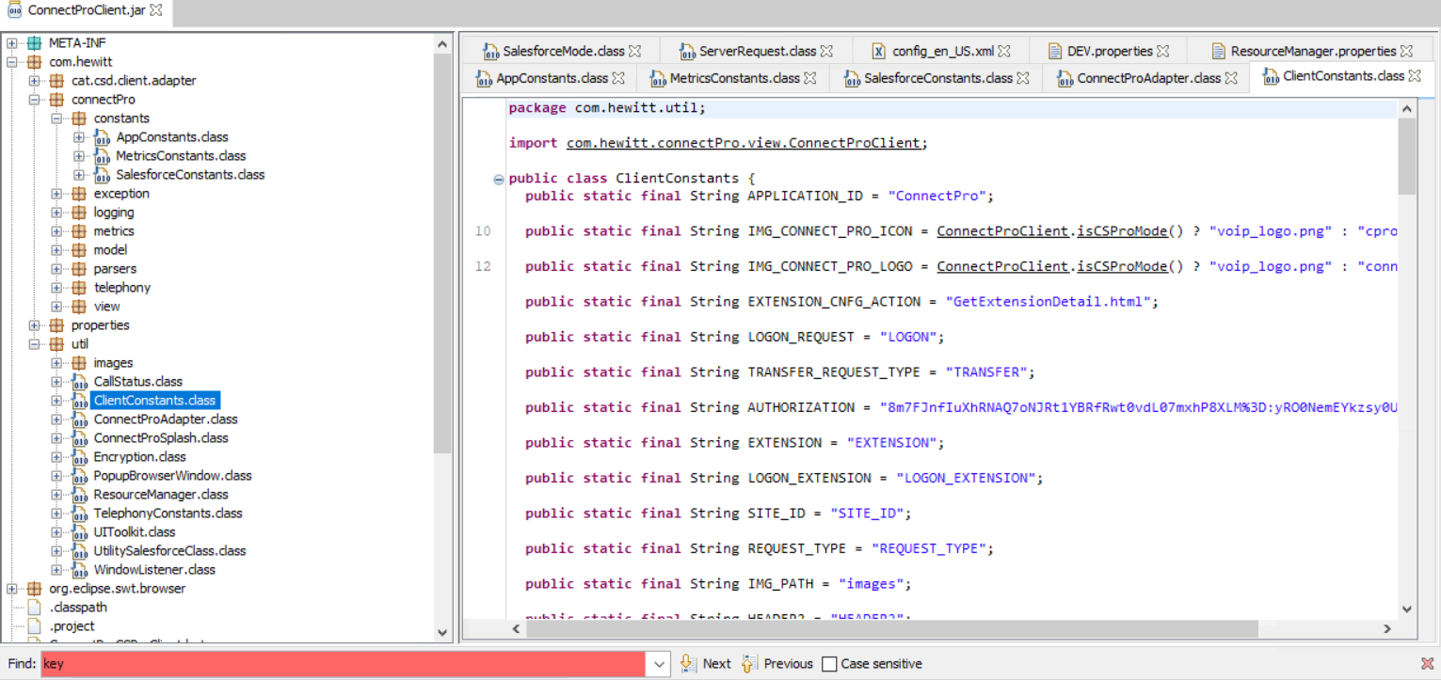
Figure 2: The AUTHORIZATION header is hardcoded into the application.

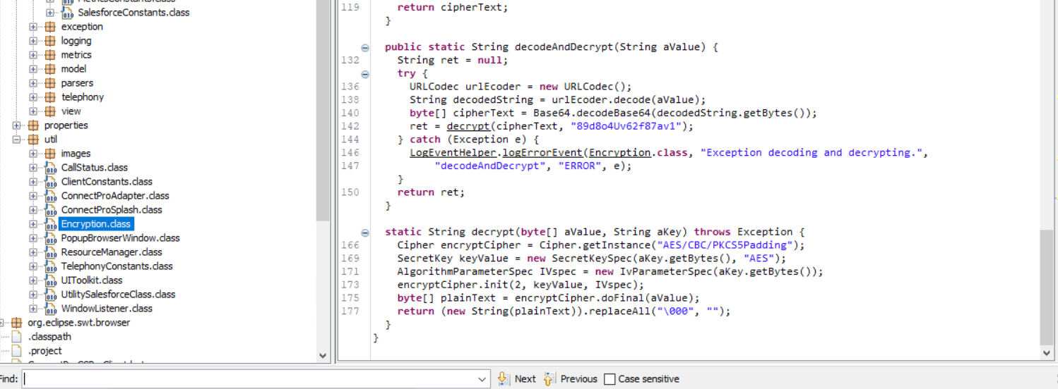
Figure 3: The encryptAndEncode function contains hardcoded key.

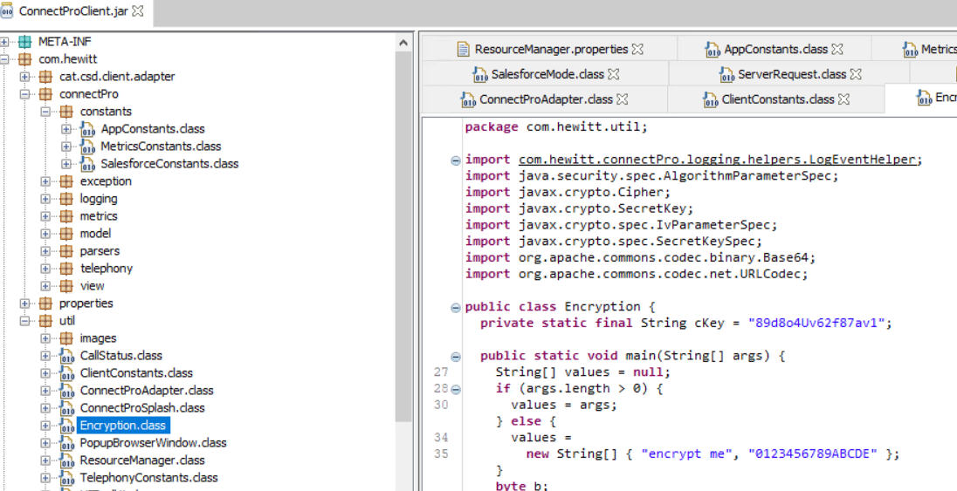
Figure 4: The String ckey contains hardcoded key.

Likelihood: Low

Impact: Low

Severity: Low

CWE ID: 798

Remediation:
In general, do not hard code secrets into source code that will end up compiled into an application. However, this can be difficult. Some common scenarios and their respective remediation are discussed below.
- Scenario 1: The device needs to encrypt data to protect it only during transmission to the server, where it will be decrypted. In this case, using TLS (optionally, with certificate pinning in the mobile application) should be the primary control. If it is desirable to encrypt data sent inside the TLS channel (e.g. to protect against potential TLS vulnerabilities), then generate an asymmetric key pair on the server and include the public key in the application binary/package. When encrypting data to send to the server, generate a random symmetric key, encrypt data with it, encrypt the symmetric key using the public key and send the encrypted data and the encrypted symmetric key to the server. Attackers will be able to reverse engineer the binary and extract the public key; however, this key will not allow them to decrypt traffic from other devices.
- Scenario 2: The device needs to decrypt data that is encrypted by a server (non-DRM scenarios where only transport protection is needed). As discussed in scenario 1, TLS should be the primary control. Additionally, if needed, have the application generate an asymmetric key pair when the user first authenticates and provide the public key to the server. Then, when the server needs to encrypt data to send to a device, generate a random symmetric key, encrypt data with it, encrypt the symmetric key using the target device's public key, and send the encrypted data and the encrypted symmetric key to the device.
- Scenario 3: The device needs to decrypt data that is encrypted by a server (DRM scenarios where the key also needs to be protected in memory while in use). In such cases, the device needs to use a unique secret or seed per device. Consider using white-box cryptography and harden the application using a commercial tool to prevent code lifting attacks.
- Scenario 4: The device needs to encrypt data to store locally and needs the ability to decrypt it later. In this case, generate a cryptographic key using user input such as a password or strong passcode. This key can be used to encrypt the data before storing the data securely on the device. Each time the user authenticates to the app using the password, the key can be regenerated in the same manner to decrypt the data for use. Application hardening using a commercial tool can also be utilized to make it difficult for an attacker to reverse engineer this logic.
Avoid hard-coding secrets within the application package and instead generate random, per-user, per-device secrets where possible. Consider fetching API keys from the application server at the first launch of the application rather than hard-coding them within the application. This also affords the ability to rotate the API keys in use when necessary.

Weak Password Policy
Description:
The application does not enforce a strong password policy to prevent malicious users from manually guessing or brute-forcing legitimate account passwords. Weak password policies include those that allow passwords consisting of common dictionary words, commonly-used passwords (e.g., 1234), known compromised passwords, passwords that contain the associated username, sequential characters, and passwords shorter than 8 characters. By allowing users to create weak passwords, an attacker can use consecutive login attempts to determine simple passwords. Many attacks use a technique called 'credential stuffing', where known combinations of usernames/passwords from various database breaches are used to target systems where the same credentials may have been used. Weak password policies may also make it easier to crack passwords in an offline attack where the attacker has gained access to the raw contents of the password database through some other means.
A weak password policy increases the likelihood that an attacker may compromise a user's account. Once compromised, an attacker has full access to the victim's account, potentially including the ability to modify settings, features, and passwords. If the target account holds administrative privileges, the attacker may be able to modify data for other users, or compromise the entire system. Due to the prevalence of password reuse, a compromised password may also provide an attacker with credentials that can be used to attack other systems the victim uses the same credentials to access.

Instances:
- CS Pro thick client application

Steps to Reproduce:
- Login into the CS Pro application using your userid and weak password.
- Observe that passwords containing only lowercase and integers are accepted by the application.

Likelihood: Low

Impact: High

Severity: Low

CWE ID: 521

Remediation:
Implement a strong password policy that combines rules to prevent easily-guessable and known passwords from being used while also ensuring that passwords contain sufficient entropy. Implementing a strong password policy minimizes the likelihood that an attack is successful if an attacker attempts to guess commonly-used passwords or employs an automated dictionary attack against a particular user. If company policy does not stipulate password requirements, or the existing requirements are weak, consider employing the following password requirements:
- Passwords must be at least eight (8) characters long.
- The application must compare the end user's selected password against a list of commonly used, expected, or compromised passwords. This list may include but is not limited to: dictionary words, commonly-used passwords, repetitive or sequential characters, context-specific words (e.g., company name, application name, or username), and passwords that have been compromised in a known data breach. The application must reject the user's password if found to breached and provide a reason for rejection to the user.
- The application must generate at least six (6) characters long passwords when creating temporary passwords such as first-time login passwords. The user must be required to update their passwords next time they log in.
- The application must enforce password change if there is evidence of compromise. Users frequently reuse passwords across different organizations. There are both online and offline methods to check for known or breached passwords, e.g., https://haveibeenpwned.com/Passwords provides an online API and large offline lists for download. See https://haveibeenpwned.com/API/v2#PwnedPasswords for more details about the API and read https://www.troyhunt.com/ive-just-launched-pwned-passwords-version-2/#cloudflareprivacyandkanonymity to understand better how it works. Other lists of known/weak passwords of various lengths and sizes can be found at https://github.com/danielmiessler/SecLists/tree/master/Passwords/Common-Credentials.

Lastly, Synopsys recommends the following best practices:
- The application should allow at least 64 characters long passwords and must not perform truncation.
- The application should provide a password strength meter to assist the user in choosing a strong password.

Minimal Priority Findings

Concurrent Sessions
Description:
The Service Connect application allows concurrent sessions; multiple users are able to login to the application simultaneously with the same user credentials.
An application that allows concurrent sessions provides an attacker with the ability to establish an active session while the victim remains logged in. This simultaneous access to the application prevents users from determining if their account has been compromised and removes the victim's ability to invalidate the attacker's session. Without the means to terminate an attacker's session, the attacker will be able to impersonate the victim in the application for the life of the session.
The use of concurrent sessions can also lead to a lack of user accountability in the system if credentials are shared among the user base. Once a set of credentials is shared by multiple users it becomes difficult (if not impossible) to tie actions to a particular user.
Instances:
- CS Pro thick client
Steps To Reproduce:
- Open an instance of CS Pro and login using your credentials.
- Open second instance of CS Pro and authenticate using the same credentials.
- Observe that two sessions are active with the same user.

Evidence:
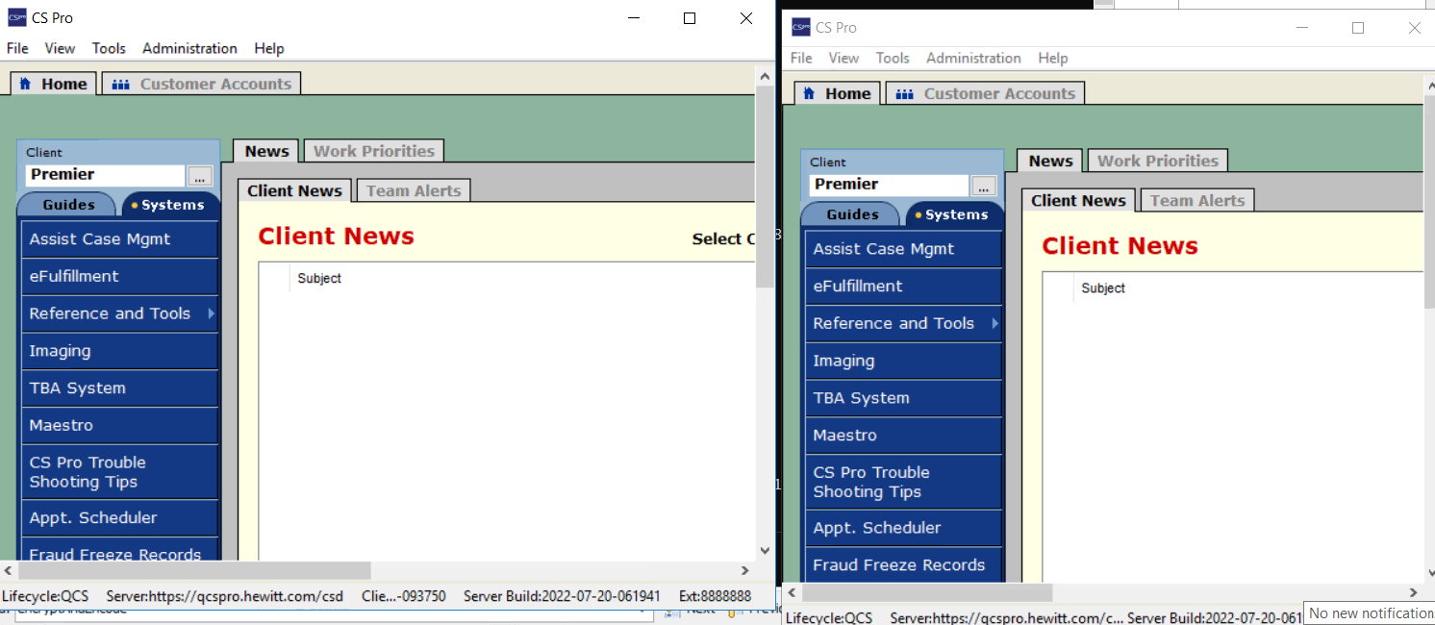
Figure 5: The user is logged in twice using same credentials.
Likelihood: Minimal
Impact: Low
Severity: Minimal

CWE ID: 930
Remediation:
The application should only allow a user to establish a single session with a particular set of credentials at a time. Once that session has been established, subsequent attempts to login using those credentials should either be denied or existing sessions should be terminated, depending on business needs.
If concurrent sessions are required for business purposes, additional session management features must be provided to ensure that all end users are made aware of multiple sessions. Such features include allowing end users to view all current sessions, prompting users when a new session is created, and providing users the ability to terminate unwanted sessions. Additionally, when allowing concurrent sessions it is recommended that users are notified that their credentials were used to establish a new session, including the time and IP from which the session was established.

The Synopsys Difference
Synopsys helps development teams build secure, high-quality software, minimizing risks while maximizing speed and productivity. Synopsys, a recognized leader in static analysis, software composition analysis, and application security testing, is uniquely positioned to apply best practices across proprietary code, open source, and the runtime environment. With a combination of industry-leading tools, services, and expertise, only Synopsys helps organizations maximize security and quality in DevSecOps and throughout the software development life cycle.
For more information, go to www.synopsys.com/software.

